Christmas Bell Ornament
- Stock size – 2 x 2 x4; any hardwood
- Mark centers, turn between centers to a cylinder
- Cut 3/8” spigot on one end to fit your chuck
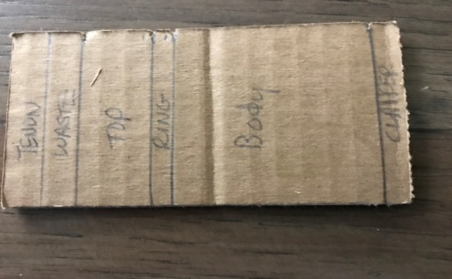
- Layout dimensions (total 4”) with or without a template (see included) as follows:
  - Spigot/Tenon – 3/8”
  - Waste – 3/8”
  - Bell Top – 3/4"
  - Ring between top and body – 1/4”
  - Bell body – 2”
  - Clapper – 1/4”
- Square up bottom with a skew
- Cut clapper about 3/8” thick using a peeling cut with a skew and round off end using a detail gouge
- Turn a bead at bottom of bell body sized about 1/4”
- Size bell body just below ring to 1&1/8” to 1&1/4” with a parting tool
- Size bell top just above ring to 1&1/8” to 1&1/4” with a parting tool (match to bell body)
- Reduce ring diameter to about 1/4" bigger than size used in #8 and #9, clean up with skew and round off to be a bead
- Shape bell body between bead and ring
- Shape bell top leaving about 3/8” unfinished at very top
- Add burn lines at bead on bottom of bell body and either side of the ring
- Sand as needed
- Finish – suggest sanding sealer, Hampshire grit or Ack’s Abrasive Sanding Paste (or similar product), wax or friction polish (Shellawax Friction Polish)
- Cut off bell with a parting tool plus skew or detail gouge
- Clean up and finish top of the top of the bell and add an eyelet
